The Dog occupies the eleventh position in the Chinese zodiac. The 12 zodiac animals are, in order: Rat, Ox, Tiger, Rabbit, Dragon, Snake, Horse, Goat, Monkey, Rooster, Dog, and Pig. Each year is related to a Chinese zodiac animal according to the 12-year-cycle.

* **Years of the Dog:** …1922, 1934, 1946, 1958, 1970, 1982, 1994, 2006, 2018, 2030…
* **Lucky numbers:** 3, 4, 9
* **Lucky colors:** red, green, and purple
* **Lucky flowers:** rose, cymbidium orchids

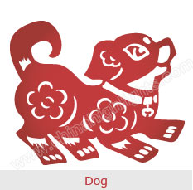

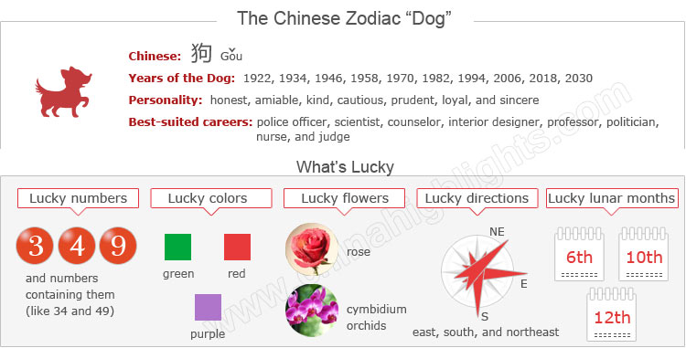

Are You a "Dog"?

The Chinese zodiac year is usually said to start from Chinese New Year, whose date ranges from late January to late February. Therefore, if you were born in January or February of the above years, you might be a Dog or a Rooster. You can use the tool on the right to find your zodiac animal sign.

Choose your date of birth and find out about your Chinese zodiac sign.



The Dogs' Personality: Loyal, Honest...

Dogs are loyal and honest, amiable and kind, cautious and prudent. Due to bearing a strong sense of loyalty and sincerity, Dogs will do everything for the person who they think is most important.

As Dogs are not good at communication, it is difficult for them to convey their minds to others. Thus Dogs tend to leave others **the impression of a stubborn personality**.

**Born with a good nature**, Dogs do not tend to be criminals or seek dishonest gain. They just need a quiet life and a good family, and thus forget the ugliness and evil on earth.

**Dogs are always ready to help others**, and do not care about their own interests, but if they find themselves betrayed by cunning people they will feel shocked and hurt.

**When thrown into doubt**, Dogs think the world is evil and complicated. Then they criticize sharply when giving comments on something, and infer all things are according to their pessimistic point of view.

Good Health for "Dogs"

Overall Dogs enjoy good health for they tend to be happy all the time. Dogs are active at doing sports, so they are resilient to illnesses such as colds, coughs, and fever.

In heavy work and frequent social activities, in addition to proper excise, they should pay attention to having enough rest, which will benefit both physical and mental health. Since Dogs are far from crazy about seeking money and power, they feel less stressed and tense at work and in life.

Best-Suited Careers for "Dogs"

Due to loyalty in personality, Dogs tend to choose a career based on the principle of serving others. Dogs are seen as valuable employees, as they work heart and soul at their tasks.

They are easy-going and kind, and always are ready to alleviate the workload of others, which make them very popular in their work circle.

**Recommended careers for Dogs** include police officer, scientist, counselor, interior designer, professor, politician, priest, nurse, clerk, and judge.

How to Build Relationships with "Dogs"?

**When making close friends**, Dogs will take some time to gain a thorough knowledge of their friends, due to their trait of being conservative and cautious. Once they become close friends, Dogs will be faithful to maintain the relationship.

They would rather suffer loss than make trouble for others, and never go against their hearts to do an immoral thing.

**In love relationships**, Dogs will not easily fall in love with someone. But once they fall in love with someone, they will have great faithfulness to maintain the love relationship and be loyal to the lover. However, their emotions have ups and downs in dealing with love relationships.

Are Dogs Compatible with You?

Each animal sign has its unique characteristics. Love compatibility within the Chinese zodiac animals works on the principle that only those whose characteristics match have good compatibility. Those who don’t match need to put more effort into their relationships.

See below for the compatibility of the Dog with other animals, and find out if the Dog is compatible with your sign or not.

* **Best with:** Rabbit
* **Worst with:** Dragon, Goat, Rooster

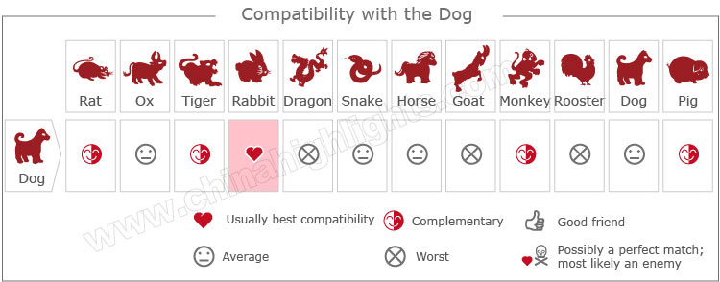

[Take our online love Compatibility test](http://www.chinahighlights.com/travelguide/chinese-zodiac/compatibility.htm)

The Luckiest Things for "Dogs"

* **Lucky numbers:** 3, 4, 9, and numbers containing them (like 34 and 49)
* **Lucky days:** the 7th and 28th of every Chinese lunar month
* **Lucky colors:** red, green, and purple
* **Lucky flowers:** rose, cymbidium orchids
* **Lucky directions:** east, south, and northeast
* **Lucky months:** the 6th, 10th, and 12th Chinese lunar months

Unlucky Things for "Dogs"

* **Unlucky colors:** blue, white, gold
* **Unlucky numbers:** 1, 6, and 7
* **Unlucky direction:** southeast
* **Unlucky months:** the 5th and 8th Chinese lunar months

Is 2015 a Lucky Year for "Dogs"?

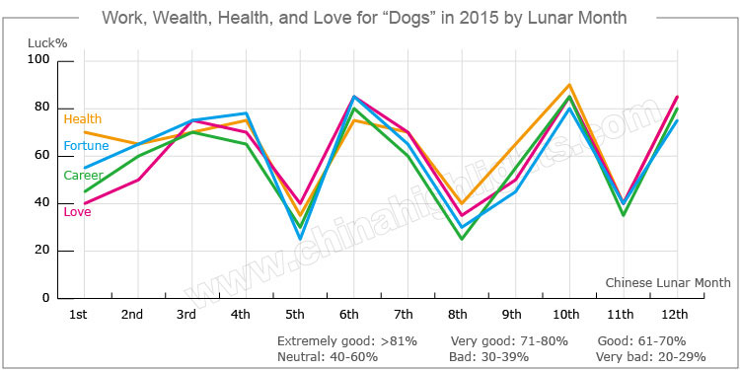

Overall, fortune for people born in a year of the Dog is not very good in 2015. However, it is better than that in 2014. There will be many setbacks in their love relationships and careers, and their health will not be so good.

Love and Relationships

The romantic life of Dogs will not be very good in 2015; **quarrels** between lovers and couples will happen from time to time, and their emotions will be up and down. Dogs should communicate more with their partners to avoid arguments, and tolerate each other when arguments appear.

However, it will be **an ideal time for devoted lovers to get married**.

**Single Dogs** will have chances to meet many friends of the opposite sex by taking part in social activities, but they have little chance to meet their true love in 2015. They should be patient, because love needs time to build its foundation. It is advisable for single Dogs to handle their interpersonal relationships well to avoid serious trouble.

Good Money-Making Opportunities

**Financial fortune** shall be good enough in the 3rd, 6th, 9th, 10th and 12th Chinese lunar months for Dogs to plan some important business in these months. However, Dogs should be careful in the 1st, 4th, 5th, 7th, 8th and 11th Chinese lunar months, because they may have financial losses.

**It is recommended** that Dogs [purchase](http://www.chinahighlights.com/travelguide/chinese-zodiac/dog.htm) stable properties instead of making high-risk investments. They are also advised not to lend money to others, and to be cautious with their money in case of being cheated.

Negative Career Path for “Dogs” in 2015

**Dogs will have negative fortune** in their careers in 2015. Although they will have a stable income, numerous problems will emerge at work. They are not expected to have promotions or salary increases in 2015. Fortunately, Dogs will get help from benefactors when they are in trouble.

**Dogs’ career luck** will be good in the 2nd, 3th, 6th, 10th, and 12th Chinese lunar months; Dogs should try to seize any possible opportunities to develop their careers in these months.

**Dogs should** improve their work skills, and keep motivated in their work, and by doing so their bosses or leaders will pay attention to them.

**Dogs are suggested** to keep a good relationship with their colleagues and bosses, because they will offer Dogs help when they have difficulties in work.

More Health Risks for “Dogs” in 2015

Dogs should pay special attention to their physical health in 2015. They should keep a healthy diet, eat more plain food, and avoid hot and spicy food in case of gastrointestinal problems. They should see a doctor as soon as possible when they fell unwell. It is also advisable for them to do moderate exercise each day.

Dogs should be careful in driving and traveling in case of accidents. They are not advised to take part in dangerous outdoor activities like bungee jumping, skiing, and rock climbing.

Five Types of "Dog", Which One Are You?

In Chinese element theory, each zodiac sign is associated with one of the five elements: Gold (Metal), Wood, Water, Fire, and Earth. For example, a Wood Dog comes once in a 60-year cycle.

|  |  |  |
| --- | --- | --- |
| **Type of Dog** | **Year of Birth** | **Characteristics** |
| Wood Dog | 1934, 1994 | Sincere, reliable, considerate, understanding, and patient |
| Fire Dog | 1946, 2006 | Intelligent, hard-working, and sincere |
| Earth Dog | 1958, 2018 | Communicative, serious, and responsible in work |
| Gold Dog | 1910, 1970 | Conservative, desirable, cautious, and always ready to help others |
| Water Dog | 1922, 1982 | Brave and self-centered, even seemingly selfish; well-versed in dealing with financial issues |

It is theorized that a person's characteristics are decided by their birth year's zodiac animal sign and element. So there are five types of Dogs, each with different characteristics: