The Horse occupies the seventh position in the Chinese Zodiac. The 12 zodiac animals are, in order: Rat, Ox, Tiger, Rabbit, Dragon, Snake, Horse, Goat, Monkey, Rooster, Dog, and Pig. Each year is related to a Chinese zodiac animal according to the 12-year-cycle.

* **Lucky Colors:** yellow and green
* **Lucky Numbers:** 2, 3, 7, and numbers containing them (like 23 and 37)
* **Lucky Flowers:** calla lily and jasmine
* **Years of Birth:** ...1918, 1930, 1942, 1954, 1966, 1978, 1990, 2002, 2014, 2026...

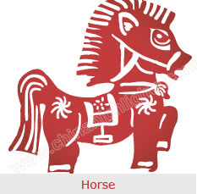

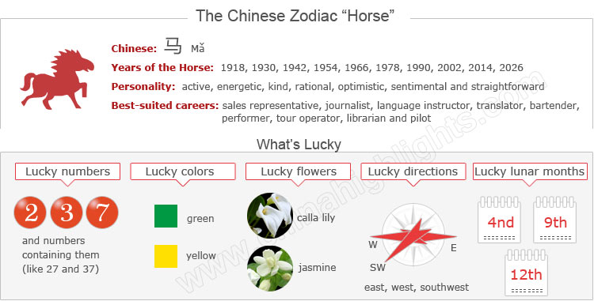

Are You a Horse?

Unless your birthday falls in January or February, you can be sure you are a Horse if you were born in one of the years mentioned above. If your birthday fell before Chinese New Year in your birth year in one of the years above, then you will be a Snake, the zodiac sign before the Horse.

You can use the tool on the right to find your zodiac animal sign.

Choose your date of birth and find out about your Chinese zodiac sign.



Health

Are You a Horse? Unless your birthday falls in January or February, you can be sure you are a Horse if you were born in one of the years mentioned above. If your birthday fell before Chinese New Year in your birth year in one of the years above, then you will be a Snake, the zodiac sign before the Horse. You can use the tool on the right to find your zodiac animal sign.

The Horses’ Personality: Active, Energetic...

People born in a year of the Horse are extremely animated, active and energetic. Horses love to be in a crowd, and they can usually be seen on such occasions as concerts, theater performances, meetings, sporting events, and parties.

With a deft sense of humor, Horses are masters of repartee. They love to take center stage and delight audiences everywhere.

Sometimes, the Horse is a little self-centered, but it doesn't mean that s/he can not be interested in others' problems. Horses are really more cunning than intelligent, and that is probably why most Horse people lack real confidence.

Good Health for "Horses"

Basically Horses are very healthy, most likely because they hold a positive attitude towards life. However, heavy responsibility or pressure from their job may make them weak. Therefore Horses shouldn't do overtime too often, and then come home very late. Also Horses should refuse some invitations to parties at night.

What Are the Best Careers for "Horses"

Jobs involving communicating with others attract Horses most. The Horse sign stands for leadership, management, and decision-making. Horses dislike taking orders.

The Horse can make it in any career that demands neither solitude nor meditation, for he is an extrovert and he needs to be surrounded by people who approve of him and flatter him.

Good career choices for Horses include: publicist, sales representative, journalist, language instructor, translator, bartender, performer, tour operator, librarian or pilot.

How to Build Relationships with "Horse People"?

People born in a year of the Horse have a pleasant, amiable, easy-going disposition. With good humor and geniality, they are extremely comfortable to get along with, as they have the ability of instantly putting people at their ease.

Horses are very quick-witted and are right in there with you before you have had the chance to finish what you were saying; they are on to the thought in your mind even before you've expressed it. All these guarantee their popularity and a large following of friends.

The Luckiest Things for "Horses"

* **Lucky numbers:** 2, 3, 7, and numbers containing them (like 23 and 37)
* **Lucky days:** the 5th and 20th of Chinese lunar months
* **Lucky colors:** yellow and green
* **Lucky flowers:** calla lily and jasmine
* **Lucky direction:** east, west, and southwest
* **Lucky months:** the 4th, 9th, and 12th Chinese lunar months

The Unlucky Things for "Horses"

* **Unlucky color:** blue, white
* **Unlucky numbers:** 1, 5, and 6
* **Unlucky direction:** north and northwest
* **Unlucky months:** the 5th, 7th, and 11th Chinese lunar months

Is the Year 2015 a Lucky Year for "Horses"?

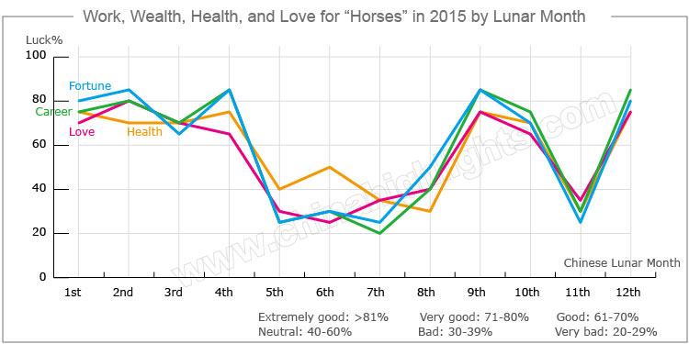

Horses are just finishing their most unlucky year of the cycle (2014 is an unlucky birth sign year for horses). Compared with 2014, 2015 will be a much smoother year for them. Horses are expected to have good fortune in all aspects in their lives.

Love and Relationships

In 2015 people born in a year of the Horse will have a great love relationships year.

**Single horses** should take part in more social activities, and they will meet their ideal partners.

**For Horses in love**, they can build their love relationship deeper. It will be auspicious for them to get married in 2015.

**For married couples**, they should take more time to be with their partners and enjoy their love lives.

Good Money-Making Opportunities

People who were born in a year of the Horse will have good fortune in 2015. Their income will increase steadily, and they might have increasing chances to earn extra income. Horses should consider making a smart investment.

However, they should avoid investing in the stock market.

Horses are suggested not to indulge in speculative spending (like the lottery), and treat such things as occasional recreational activities. They are also not advised to lend money to avoid getting into unexpected trouble.

A Smooth Career Path for "Horses" in 2015

The careers of Horses will tend to be good in 2015. Although Horses will meet many challenges, they will be able to overcome them successfully with their intelligence and diligence.

Clerks will attain great achievements in their jobs, and their bosses or leaders will start to attach more importance to their performance. They are expected to get a promotion and a salary increase.

For Horses who operate businesses, it will be fairly easy for them to get more contracts and profit from them, and will also be an excellent chance for them to carry out new projects due to support from coworkers and friends.

Therefore Horses are suggested to get along very well with their business partners and friends. Try to accept what others suggest and try to understand their points of view.

Good Health for “Horses” in 2015?

People born in a year of the Horse will have good health on the whole, however they should pay more attention to their blood pressure, especially elderly people. At the same time, those who are fond of wine should drink less.

Horses should avoid overworking and take enough rest. Regular physical examinations are necessary for them to avoid some unexpected illnesses. Extreme outdoor sports (like hang-gliding, bungee jumping, and skiing) should be avoided too.

Love Compatibility of the Horse with Other Animals

Each animal sign has its unique characteristics. Love compatibility within the Chinese zodiac animals takes the characteristics of each animal into account. Only those whose characteristics match each others can be good partners.

See below for the compatibility of the Horse with other animals, and find out if the Horse is compatible with your sign or not.

* **Best with** a Goat or Tiger
* **Worst with** a Rat, Ox, or Rooster

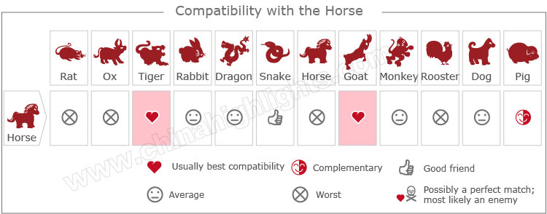[Take our online love Compatibility test.](http://www.chinahighlights.com/travelguide/chinese-zodiac/compatibility.htm)

Five Types of "Horse" — Which One Are You?

In Chinese element theory, each zodiac sign is associated with one of the five elements: Gold (Metal), Wood, Water, Fire, and Earth. A Wood Horse, for example, comes once in a 60-year cycle.

It is theorized that a person's characteristics are decided by their birth year's zodiac sign and element. So there are five types of Horses, each with different characteristics:

|  |  |  |
| --- | --- | --- |
| **Type of Horse** | **Year of Birth** | **Characteristics** |
| Wood Horse | 1954, 2014 | Irritable and sentimental, with an abundant imagination and insightful analyses of issues |
| Fire Horse | 1906, 1966 | Smart, charismatic, lively, overflowing with enthusiasm, but stubborn |
| Earth Horse | 1918, 1978 | Optimistic, kind-hearted, righteous, but irritable; with a strong sense of responsibility, and always ready to help others |
| Gold Horse | 1930, 1990 | kind, straightforward, calm, rational, always ready to help others, and popular among friends |
| Water Horse | 1942, 2002 | Sentimental, irritable, reliable, amicable, always ready to help others, and very charming for friends of the opposite sex. |