The Ox occupies the second position in the Chinese Zodiac. The 12 zodiac animals are, in order: Rat, Ox, Tiger, Rabbit, Dragon, Snake, Horse, Goat, Monkey, Rooster, Dog, and Pig. Each year is related to a Chinese zodiac animal according to the 12-year-cycle.

* **Lucky Colors:** white, yellow, green
* **Lucky Numbers:** 1, 4
* **Lucky Flowers:** tulip, morning glory, peach blossom
* **Year of Birth:** 1913, 1925, 1937, 1949, 1961, 1973, 1985, 1997, 2009, 2021

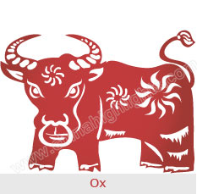

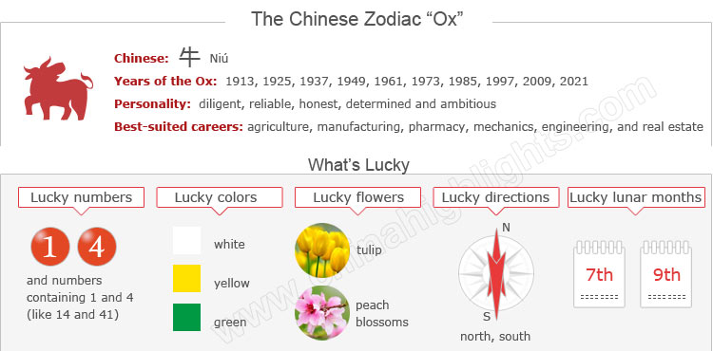

Are You an Ox?

Years of the Ox include: 1913, 1925, 1937, 1949, 1961, 1973, 1985, 1997, 2009, and 2021.

You can use the tool on the right to find your zodiac animal sign.

The Oxes’ Personality: Diligent, Dependable...

Choose your date of birth and find out about your Chinese zodiac sign.



Oxes are known for diligence, dependability, strength and determination. Having an honest nature, Oxes have a strong patriotism for their country, have ideals and ambitions for life, and attach importance to family and work. These things reflect the traditional characteristics of conservatives. Women belonging to the Ox zodiac sign are traditional, faithful wives, who attach great importance to their children's education.

Having a desire to advance and great patience, Oxes can achieve their goals by consistent efforts. They are not influenced by others or the environment, but persist to do things in accordance with their ideas and capabilities. Before taking action, they will have a definite plan with detailed steps and add their strong faith and physical strength. So people of the Ox zodiac sign enjoy great success as a result.

The most disadvantageous trait in Oxes is poor communication skills. They are not good at communicating with others, and even think it not worthwhile exchanging ideas with others. They are stubborn and stick to their own ways.

Good Health for "Oxes"

Oxes are strong and robust; they can enjoy a fairly healthy and long life, fulfilled lives, and little illness.

Because of hard work with a stubborn personality, they often spend too much time in their work, rarely allowing themselves enough time to relax, and tend to forget meals, which make them have intestinal problems. So enough rest and a regular diet are needed for Oxes to work efficiently.

With a stubborn temperament, they find it easy to bear stress and tension, and they are reluctant to reveal themselves to others. Proper relaxation and regular short trips will benefit the Ox.

The Best Careers for "Oxes"

As the symbol of hard work, Ox people always work hard at everything and stick to finishing it. Possessing a serious and responsible attitude toward work, they can come up with different approaches to their task.

With a keen eye for details and an admirable work ethic, they are competent in such careers as agriculture, manufacturing, pharmacy, mechanics, engineering, draftsmanship, artistry, politics, real estate, interior design, painting, carpentry, or quarry work.

How to Build Relationships with "Ox People"?

Ox people are not good at communicating with others, so they have less social intercourse. They prefer to stay alone and enjoy solitude instead of participating in group activities. They treat friends sincerely and count much on friendship.

For love relationships, Oxen tend to keep a long term relationship with their lovers. Frequent changes of lover make them uncomfortable. Ladies of the Ox zodiac sign lack femininity. If they can realize their inadequacies, and change their cautious attitude of indifference to affection and enthusiasm, they will have love relationships to their hearts' desire.

The Luckiest Things for "Oxes"

* **Lucky numbers:** 1, 4, and numbers containing 1 and 4 (like 14 and 41)
* **Lucky days:** the 13th and 27th of every Chinese lunar months
* **Lucky colors:** white, yellow, and green
* **Lucky flowers:**tulip, morning glory, and peach blossom
* **Lucky direction:** north and south
* **Lucky months:** the 7th and 9th Chinese lunar months

Things That Should Be Avoided by "Oxes"

* **Unlucky color:**blue
* **Unlucky numbers:**5 and 6
* **Unlucky direction:**southwest
* **Unlucky months:** the 4th and 11th Chinese lunar months

Is the Year 2015 a Lucky Year for “Oxes”?

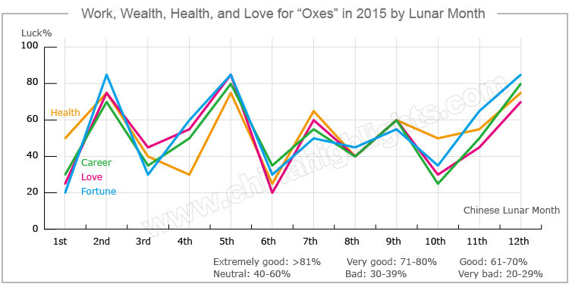

2015 is a year of the goat, which will bring the Ox lots of changes in all aspects of fortune. They should be calm and flexible to accept all the changes with a positive frame of mind. Once they embrace the changes and follow the course of events, they will find 2015 to be a very enjoyable year.

Love and Relationships

The romantic life for people who were born in a year of the Ox will be bittersweet in 2015. Young lovers may often quarrel with each other; however, their relationships will not be hurt due to the mediation of their closest friends.

**Married couples** easily come to disputes and misunderstand each other. They should make allowances for each other to keep a smooth marriage.

**Single people** will spend most of their time feeling lonely due to their lack of social life. There are many romantic opportunities for the single Ox, but it is hard to find the right one.

Beware of Financial Loss

People, who were born in a year of the Ox, should be careful no matter whether investing or cooperating with others in 2015, because they are at risk of suffering unexpected personal financial losses. They should carefully control their daily financial spending, and try hard to keep expenses down. Otherwise they will be in trouble due to excessive spending. They should get along well with their friends, as they will bring them good investment opportunities in the future.

They should [purchase](http://www.chinahighlights.com/travelguide/chinese-zodiac/ox.htm) some real estate at the beginning of the year, which could change their bad luck into good fortune at the end of the year.

How to Make the Career Path Smoother in 2015?

As for Oxes’ careers, it is not very promising this year. They will be under considerable pressure at work, and their bosses will be too picky for them to bear. Chances are fewer for a promotion or a salary increase. Their work efficiency shall be significantly reduced owing to these points.

However, it is not a good idea for them to change jobs. So they must act patiently and persist in doing their job. The situation will get betterat the end of the year.

How Can "Oxes" Have Good Health in 2015?

Oxes will be vulnerable to slight illnesses this year; therefore they should be more careful to have a nutritious diet and do more exercise to reduce the chance of getting sick.

Love Compatibility: Is She/He Compatible with You?

Each animal sign has its unique characteristics. Love compatibility within the Chinese zodiac animals mostly takes the general characteristics of each animal into account. Only those whose characteristics match each others, can be good partners. The Ox is…

* **Best with:** Rat, Monkey, or Rooster.
* **Worst with:**Tiger, Dragon, Horse, or Goat.

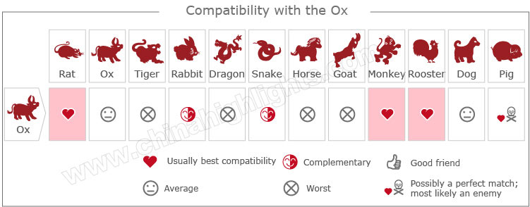

[Take our online love Compatibility test](http://www.chinahighlights.com/travelguide/chinese-zodiac/compatibility.htm)

What Type of "Ox" Are You: Wood, Fire, Earth, Gold, or Water?

In Chinese element theory, each zodiac sign is associated with one of the five elements: Gold (Metal), Wood, Water, Fire, and Earth. For example, a Wood Ox comes once in a 60-year cycle.

It is theorized that a person's characteristics are decided by their birth year's zodiac animal sign and element. So there are five types of Oxes, each with different characteristics:

|  |  |  |
| --- | --- | --- |
| **Type of Ox** | **Year of Birth** | **Characteristics** |
| Wood Ox | 1925, 1985 | Restless, decisive, straightforward, and always ready to defend the weak and helpless |
| Fire Ox | 1937, 1997 | Short-sighted, selfish, narrow-minded, impersonal, but practical |
| Earth Ox | 1949, 2009 | Honest and prudent, with a strong sense of responsibility |
| Gold Ox | 1961, 2021 | Hardworking, active and always busy, and popular among friends |
| Water Ox | 1913, 1973 | Hardworking, ambitious, tenacious, able to endure hardship, with a strong sense of justice and keen observational abilities |