The Rooster is tenth in the Chinese zodiac. Each year is related to an animal sign according to a 12-year cycle. Years of the Rooster include 1921, 1933, 1945, 1957, 1969, 1981, 1993, 2005, 2017, and 2029.

* **Lucky Colors:** gold, brown, yellow
* **Lucky Numbers:** 5, 7, and 8
* **Lucky Flowers:** gladiola, cockscomb

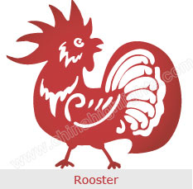

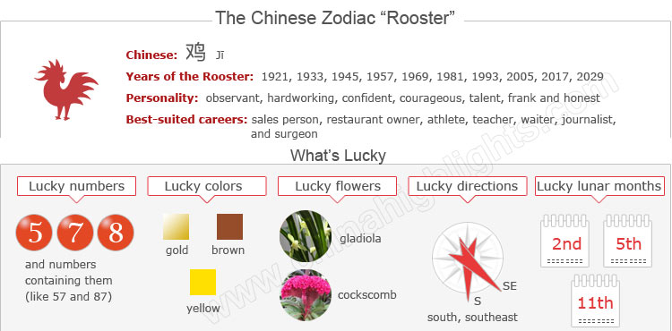

Are Years of the Rooster Lucky for Roosters?

According to Chinese astrology, the year of one’s birth sign (本命年 běnmìngnián /bnn-ming-nyen/ ‘origin (of) life year’) is the most unlucky year in the 12-year cycle. In the year of your sign, fortune in all aspects of your life will not be as good.

Therefore “Roosters” should be more careful in years of the Rooster. Read more on How to Be Lucky in Your Ben Ming Nian.

The next Rooster year is 2017. It starts on Chinese New Year's day (January 28, 2017). Roosters born in January and February should take particular note of when Chinese New Year falls to confirm their birth sign.

Choose your date of birth and find out about your Chinese zodiac sign.



The Rooster's Personality: Observant, Hardworking...

People born in a year of the Rooster are very observant. Hardworking, resourceful, courageous and talented, Roosters are very confident about themselves.

Roosters are always active, amusing and popular among the crowd. Roosters are talkative, outspoken, frank, open, honest, and loyal individuals. They like to be the center of attention and always appear attractive and beautiful.

Roosters are happiest when they are surrounded by others, whether at a party or just a social gathering. They enjoy the spotlight and will exhibit their charm at any occasion.

Roosters expect others to listen to them while they speak, and can become agitated if others don't. Vain and boastful, Roosters like to brag about themselves and their accomplishments.

Their continually seeking the unwavering attention of others annoys people around them at times.

Good Health for "Roosters" People born in a year of the Rooster are typically healthy people. They are active and enjoy sports such as hiking and swimming. Roosters don't get sick very often because they tend to fight illness well. Even when they do become ill, they feel better quickly. Roosters are a little sensitive, and they feel stressed and moody at times.

The Best Jobs and Careers for Roosters

Roosters are more motivated than other animals in the Chinese zodiac, making their careers a priority in their lives. Roosters are hard working, multi-talented, and can deal with a variety of jobs.

Good career choices for Roosters are newsreader, sales person, restaurant owner, hairdresser, public relations officer, farmer, athlete, teacher, waiter, journalist, travel writer, dentist, surgeon, soldier, fireman, security guard, and police officer.

How to Build Relationships with "Roosters"

Roosters are loyal and they make devoted friends. They always keep their promises and are always true to their word. Sensitive individuals may find it hard to get along well with Roosters, because they always brag about themselves and their accomplishments, which may make others uncomfortable.

The Luckiest Things for "Roosters"

* **Lucky numbers:** 5, 7, and 8
* **Lucky days:** the 4th and 26th of any Chinese lunar month
* **Lucky colors:** gold, brown, yellow
* **Lucky flowers:** gladiola, cockscomb
* **Lucky direction:** south, southeast
* **Lucky months:** the 2nd, 5th, and 11th Chinese lunar months.

Things That Roosters Should Avoid

* **Unlucky color:** red
* **Unlucky numbers:** 1, 3, and 9
* **Unlucky direction:** east
* **Unlucky months:** the 3rd, 9th, and 12th Chinese lunar months

2015 for "Roosters" — a Bad Year

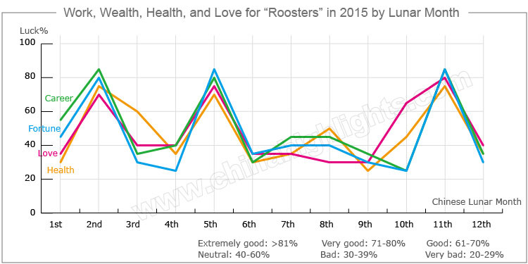

2015, a year of the Goat, will be a very challenging year for people born in a year of the Rooster. Fortune in all aspects of their lives, including love relationships, finance, career, and health will not be very smooth. They should keep positive attitudes to their lives and be patient.

Love and Relationships

Roosters' romantic lives will not be very good in 2015.

Single people may have several potential pursuers, but none of them will be the right person.

Roosters in love and Married couples will have trouble spending time with their partners, resulting in an alienation of affections and arguments amongst couples. They should be patient and communicate more with each other.

Beware of Financial Loss

Fortune in Roosters’ finances will not be good in 2015. They should be doubly cautious as far as their finances are concerned. Roosters are likely to lose money when they do business or make investments.

Roosters should plan their savings and expenditure well, which may help them get through any financial storms in the future.

It is inadvisable for Roosters to lend money to friends and relatives in 2015, as harmonious relationships are likely to be hurt due to money.

Roosters' Careers in 2015

There will be sudden and unpleasant changes in Roosters’ careers and business in 2015. Their careers will encounter setbacks. Great pain and little gain will soon make them weary in 2015, therefore it is advisable for them to study more in their spare time to improve themselves for challenges in the future.

Roosters should control their tempers and focus on teamwork, act more and speak little, and their careers will stabilize by the end of the year.

How Roosters Can Improve Their Health Outlook in 2015

The outlook for health is not very optimistic. There may be a health crisis looming this year for Roosters or their families, so they should pay more attention to their daily diets, and do some appropriate sporting exercise to release stress.

Roosters will also be vulnerable to disasters in 2015, so Roosters should be careful when driving and avoid taking part in adventurous activities.

Love Compatibility for Roosters

Each animal sign has its unique characteristics. The love compatibility of Chinese zodiac animals takes into account the characteristics of each animal. Only those whose characteristics match well can be good partners. See below the compatibility of the Rooster with other animals.

* **Best with** an Ox or Snake
* **Worst with** a Rat, Rabbit, Horse, or Pig

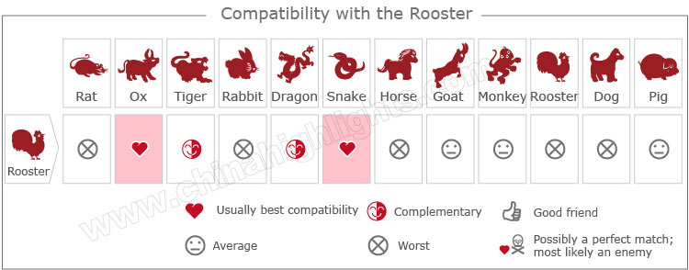

[Take our online love Compatibility test](http://www.chinahighlights.com/travelguide/chinese-zodiac/compatibility.htm)

Five Types of "Roosters", What Type Are You?

In Chinese element theory, each zodiac sign is associated with one of five elements: Gold (Metal), Wood, Water, Fire, or Earth, which means that e.g. a Wood Rooster comes once in a 60-year cycle.

It is theorized that a person's characteristics are decided by their birth year's zodiac animal sign and element. So there are five types of Roosters, each with different characteristics:

|  |  |  |
| --- | --- | --- |
| **Type of Rooster** | **Year of Birth** | **Characteristics** |
| Wood Rooster | 1945, 2005 | Energetic, over-confident, tender and unstable |
| Fire Rooster | 1957, 2017 | Trustworthy, with a strong sense of timekeeping and responsibility at work. |
| Earth Rooster | 1909, 1969 | Lovely, generous, trustworthy, and popular in their friends. |
| Gold Rooster | 1921, 1981 | Determined, brave, perseverant, and hard working |
| Water Rooster | 1933, 1993 | Smart, quick-witted, tender-hearted, and compassionate |