The Tiger ranks the third of the animals in the Chinese zodiac. The 12 zodiac animals are, in order: Rat, Ox, Tiger, Rabbit, Dragon, Snake, Horse, Goat, Monkey, Rooster, Dog, and Pig. Each year is related to an animal sign according to a 12-year-cycle.

* **Lucky Colors:** blue, grey, orange, white
* **Lucky Numbers:** 1, 3, 4
* **Lucky Flowers:** yellow lily, cineraria
* **Year of Birth:** 1914, 1926, 1938, 1950, 1962, 1974, 1986, 1998, 2010, 2022

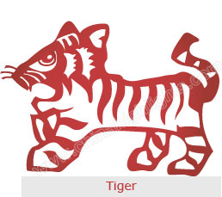

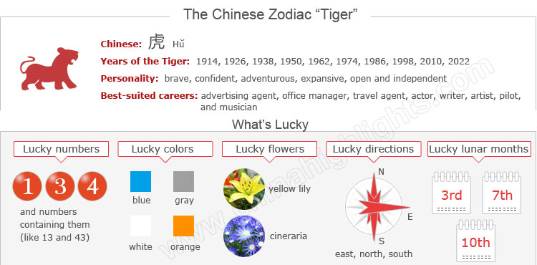

Are You a Tiger?

Years of the Tiger include 1914, 1926, 1938, 1950, 1962, 1974, 1986, 1998, 2010, and 2022.

You can use the tool on the right to find your zodiac animal sign.

The Tiger’s Personality: Brave, Confident...

People born in the year of the Tiger are brave, competitive, unpredictable, and self-confident. They are very charming and well-liked by others. But sometimes they are likely to be impetuous, irritable, and overindulged.

**With stubborn personalities** and tough judgment, tigers work actively and boldly express themselves, and do things with a high-handed manner. They are authoritative and never go back on what they have said.

Choose your date of birth and find out about your Chinese zodiac sign.



**With great confidence** and indomitable fortitude, they can be competent leaders. They will not make preparations for anything, but they can handle anything that comes along.

While they are not motivated by money or power,

**Tigers love be challenged** and will accept any challenge if it means important value to them, and they do not like to obey others.

Good Health for “Tigers”

Tigers enjoy good health. They are active so they like to do various sports. Small illnesses, such as colds, coughs, and fever, are rarely experienced by Tigers.

However, they should avoid excessive strenuous exercise, because some dangerous activities may lead to physical harm. When involved in outdoor excise, they should pay particular attention to warm-up exercise. Aerobic exercises, such as jogging, are suitable for keeping fit.

Tigers are energetic and have great enthusiasm at work. When they feel exhausted after extended work, they need some relaxation to refresh themselves.

The Best Jobs or Career for Tigers

The Tiger, called “the king of the animals" in China, is usually the center of attention. They are born with leadership, and they are respected by others. Tigers are suitable to any career as leaders.

They are suited to careers such as advertising agent, office manager, travel agent, actor, writer, artist, pilot, flight attendant, musician, comedian, and chauffeur.

However, in their early years, Tigers’ careers are not so smooth. After their thirties they find their direction and gather wealth.

How to Build Relationships with "Tigers"

In social relationships, Tigers are always in the dominant role.

Due to mistrust and over confidence, Tigers do not like to communicate with others, so they are not good at coordinating in social circles. They are inclined to use commanding means to deal with interpersonal relationships. Even though they are acquainted with a lot of people, they do not further the relationships to deep friendship.

Understanding, patience, and tact are needed when dealing with Tigers.

In love relationships, Tigers cannot give sweet love to their partners because they lack a sense of romance. Partners need to be equally active to keep up with the Tiger’s sense of adventure.

The Luckiest Things for “Tigers”

* **Lucky numbers:** 1, 3, and 4 and numbers containing them (like 13 and 43)
* **Lucky days:**the 16th and 27th of any Chinese lunar calendar month
* **Lucky colors:** blue, gray, orange
* **Lucky flowers:** yellow lily, cineraria
* **Lucky direction:** east, north, south
* **Lucky months:** the 3rd, 7th, and 10th Chinese lunar months.

Things That Should Be Avoided by “Tigers”

* **Unlucky colors:** brown
* **Unlucky numbers:** 6, 7, and 8
* **Unlucky direction:** southwest
* **Unlucky months:** the 1st, 4th, 5th and 11th Chinese lunar months

Is Year 2015 a Lucky Year for "Tigers"?

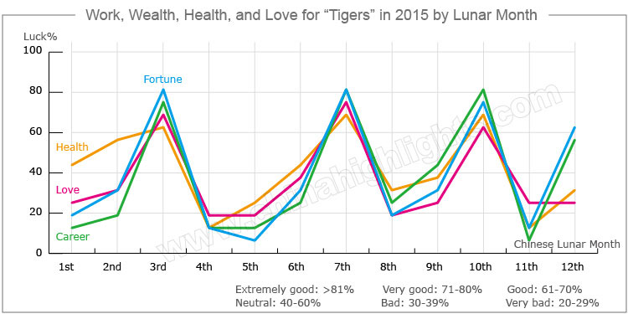

In general, 2015 is not a very smooth year for people born in a year of the Tiger. They will encounter many difficulties in all aspects of their lives. However they will overcome them with the help of their friends, and their own traits of bravery and liking challenge.

Love and Relationships

Romantic life for the Tiger will bittersweet in 2015. There will be quarrels between young lovers and married couples. They should have more active communications with each other to avoid misunderstandings.

Tigers in love are suitable to get married in 2015.

Married couples should take more time to stay with their families, and some happy events may happen at home.

Single Tigers should pay attention to the people around them in order to find their life partners.

Beware of Financial Loss

People who were born in a year of the Tiger will have poor fortune in 2015. Despite this, it is highly probable that they will win a prize in a lottery draw in 2015.

Do not lend money to others to avoid getting into unexpected troubles. It’s not a good idea to make large, impulsive purchases. Tigers should [purchase](http://www.chinahighlights.com/travelguide/chinese-zodiac/tiger.htm) something valuable at the beginning of a year that will retain its value at the end of the year.

How to Make Your Career Path Smoother in 2015?

As for their career, the Tiger will have numerous difficulties in their jobs and will have to strive very hard to deal with them all. However, they will make great achievements despite these difficulties, and will also readily get help from magnates.

Tigers are suggested to foster good relationships with their colleagues and friends; they may get helps from them when they confront difficulties in their jobs. Hard tasks are necessary for them to better their careers.

For those who operate a business, they should have a complete business plan and never make a decision hurriedly. They should listen carefully to the opinions from their families and friends.

How Can Tigers Have Good Health in 2015?

People born in the year of the Tiger will often feel tired and be vulnerable to illness. However they will recover quickly under the advice of **good doctors**.   
They will be under large mental pressure, so it is advisable for them to **try to relax**, avoid overworking, and have more rests. They should **do moderate exercise** each day to keep fit.

Love Compatibility: Is She/He Compatible with You?

Each animal sign has its unique characteristics. Love compatibility among Chinese zodiac animals mostly takes into account the general characteristics of each animal. Only those whose characteristics match each other well can be good partners. See below the compatibility of the Tiger with other animals.

* **Best with:** Dragon, Horse, or Pig
* **Worst with:** Ox, Snake, or Monkey

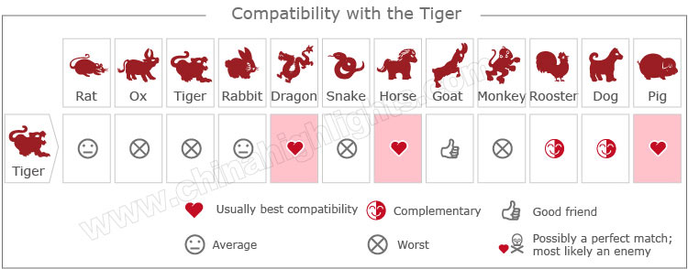

[Take our online love Compatibility test](http://www.chinahighlights.com/travelguide/chinese-zodiac/compatibility.htm)

What Type of "Tiger" Are You: Wood, Fire, Earth, Gold, or Water?

In Chinese element theory, each zodiac sign is associated with one of five elements: Gold (Metal), Wood, Water, Fire, or Earth, which means that e.g. a Wood Tiger comes once in a 60-year cycle.

|  |  |  |
| --- | --- | --- |
| **Type of Tiger** | **Year of Birth** | **Characteristics** |
| Wood Tiger | 1914, 2074 | Compassionate, expansive, and open |
| Fire Tiger | 1926, 1986 | Optimistic and independent, with poor self-control |
| Earth Tiger | 1938, 1998 | Adventurous and realistic, with strong faith |
| Gold Tiger | 1950, 2010 | Females are very enthusiastic; males are indecisive, stubborn, and feminized |
| Water Tiger | 1902, 1962 | Has a strong sense of self-esteem and learning ability |

It is theorized that a person's characteristics are decided by their birth year's zodiac animal sign and element. So there are five types of Tigers, each with different characteristics: