The monkey ranks ninth of the 12 animals in the Chinese zodiac. Each year is related to an animal sign according to a 12-year-cycle. Years of the Monkey include 1920, 1932, 1944, 1956, 1968, 1980, 1992, 2004, 2016, and 2028.

* **Lucky Colors:** white, blue, gold
* **Lucky Numbers:** 4 and 9
* **Lucky Flowers:** chrysanthemum, crape-myrtle
* **Years of birth**: … 1920, 1932, 1944, 1956, 1968, 1980, 1992, 2004, 2016, 2028…

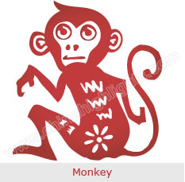

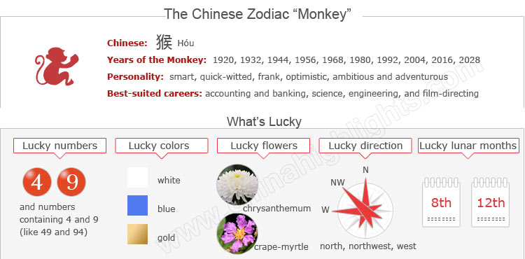

Years of Monkey – Unlucky Years for Monkeys?

The year of one’s birth sign (本命年 běnmìngnián /bnn-ming-nyen/ ‘origin (of) life year’) is believed to be the most unlucky in the 12-year cycle. “Monkeys” (who take Chinese astrology seriously) are particularly careful about their health, love lives, career, and investments in Monkey years. Read more on[How to Be Lucky in Your Ben Ming Nian](http://www.chinahighlights.com/travelguide/chinese-zodiac/how-to-bring-yourself-good-luck-on-ben-ming-nian.htm).

The next Monkey year is 2016, but it doesn’t start on January 1! Chinese Zodiac years are according to the Chinese lunar calendar, starting and ending at Chinese New Year. **People born in January or February** should take particular note of when Chinese New Year falls to confirm their birth sign.

Choose your date of birth and find out about your Chinese zodiac sign.



The Monkey's Personality: Quick-Witted, Intelligent...

People born in a year of the Monkey are witty, intelligent, and have a magnetic personality. Personality traits, like mischievousness, curiosity, and cleverness, make them very naughty. Monkeys are masters of practical jokes, because they like playing most of the time. Though they don't have any bad intentions, their pranks sometimes hurt the feelings of others.

Those born in a year of the Monkey are fast learners and crafty opportunists. They have many interests and need partners who are capable of stimulating them. While some like the eccentric nature of Monkeys, some don't trust their sly, restless, and inquisitive nature.

Although they are clever and creative, monkeys can't always exhibit their talent properly. Monkeys like to take challenges and they prefer urban life to rural.

Good Health for "Monkeys"

Usually monkeys are very healthy creatures, partly due to their active lifestyles, and wanting to experience the flavors of life. If they do experience illness, it is usually of the nervous or circulatory system.

People born in a year of the Monkey might have to spend more time doing their daily jobs. Therefore Monkeys need to remember to take a break to save their energy during their busy schedules.

Since Monkeys usually do more outdoor activities, they should to pay attention to safety while traveling or driving.

The Best Jobs or Career for Monkeys

When it comes to careers, Monkeys do work very hard. They can adapt to different working environments. Good career choices for monkeys are accounting and banking, science, engineering, stock market trading, air traffic control, film directing, jewelry, and salesmanship.

How to Build Relationships with "Monkeys"

In relationships Monkeys are not very quick in settling down, as they tend to be promiscuous and are easily bored. However, once Monkeys get a perfect partner, they commit to him/her in every possible way. Since Monkeys love to talk and are sociable, they can be communicated with easily.

Is Year 2015 a Lucky Year for “Monkeys”?

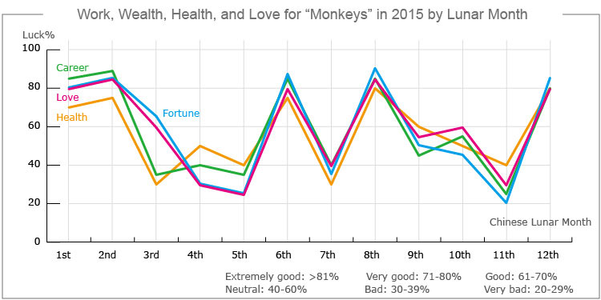

In the year of 2015, the overall trend is increase in all aspects of fortune for people born in a year of the Monkey. Compared with 2014, there will be more breakthroughs in 2015, and it will be an easier year for them.

Love and Relationships

2015 is a year of the Goat, and the Goat is complementary to the Monkey in love relationships. Therefore Monkeys’ romantic lives will be very smooth in 2015.

Single people should meet more friends of the opposite sex in order to develop a romantic relationship. People in love should consider a deeper relationship. It will be a great time for them to get engaged or get married.

Money Making Opportunities

People who were born in a year of the Monkey will have good fortune in 2015. There will be endless money-making opportunities for Monkeys, and they can get rich quickly. However, they should not pocket all the profits and destroy their source of income; they should share the profits with their business partners or customers. They should not make any investment that entails a high risk.

How to Make Your Career Path Smoother in 2015?

The year of the Goat 2015 will provide the stage for Monkeys to show off their talent. They will be the favorite workers in the company. Many people will give them a hand when they get in trouble in work. However Monkeys’ work efficiency may be influenced by poor health, so they should do exercises that enhance their strength for work.

Remember to get along well with their friends of the opposite sex, because they may bring good luck in the workplace.

How Can Monkeys Have Good Health in 2015?

Monkeys’ health will tend not to be very good and, as a result, they should get sufficient sleep and do moderate exercise to overcome risks of poor health.  
Monkey people should pay more attention to safety during outdoor activities. For example, they should drive carefully, and avoid taking part in dangerous sports, such as hang gliding, bungee jumping, and skiing.

Love Compatibility: Is She/He Compatible with You?

Each animal sign has its unique characteristics. Love compatibility within Chinese zodiac animals mostly takes into account the general characteristics of each animal. Only those whose characteristics match each other well can be good partners. See below the compatibility of the Monkey with other animals.

* **Best with:** Ox or Rabbit
* **Worst with:** Tiger or Pig

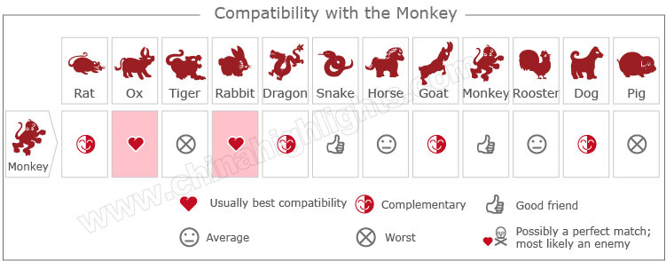

[Take our online love Compatibility test](http://www.chinahighlights.com/travelguide/chinese-zodiac/compatibility.htm)

The Luckiest Things for "Monkeys"

* **Lucky numbers:** 4 and 9
* **Lucky days:** the 14th and 28th of any Chinese lunar calendar month
* **Lucky colors:** white, blue, gold
* **Lucky flowers:** chrysanthemum, crape-myrtle
* **Lucky direction:** north, northwest, west
* **Lucky months:** the 8th and 12th Chinese lunar months.

Things That Should Be Avoided by Monkeys

* **Unlucky colors:** red, pink
* **Unlucky numbers:** 2 and 7
* **Unlucky direction:** south, southeast
* **Unlucky months:** the 7th and 11th Chinese lunar months

What Type of "Monkey" Are You: Wood, Fire, Earth, Gold, or Water?

In Chinese element theory, each zodiac sign is associated with one of five elements: Gold (Metal), Wood, Water, Fire, or Earth, which means that e.g. a Wood Monkey comes once in a 60-year cycle.

It is theorized that a person's characteristics are decided by their birth year's zodiac animal sign and element. So there are five types of Monkeys, each with different characteristics:

|  |  |  |
| --- | --- | --- |
| **Type of Monkey** | **Year of Birth** | **Characteristics** |
| Wood Monkey | 1944, 2004 | Always ready to help others. Compassionate, strong self-esteem but stubborn |
| Fire Monkey | 1956, 2016 | Ambitious and adventurous but irritable |
| Earth Monkey | 1908, 1968 | Frank, optimistic and fearless |
| Gold Monkey | 1920, 1980 | Smart, quick-witted and confident but also irritable and stubborn |
| Water Monkey | 1932, 1992 | Smart, quick-witted, fond of being in the limelight but haughty |