The year of the Dragon is fifth in the Chinese zodiac. Each year has an animal sign according to a 12-year cycle. Years of the Dragon include 1916, 1928, 1940, 1952, 1964, 1976, 1988, 2000, 2012 and 2024.

* **Lucky Colors:** gold, silver, grayish white
* **Lucky Numbers:** 1, 6, 7
* **Lucky Flowers:** bleeding-heart glory bower, dragon flowers
* **Years of Birth:** 1916, 1928, 1940, 1952, 1964, 1976, 1988, 2000, 2012, 2024

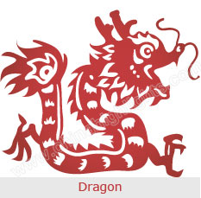

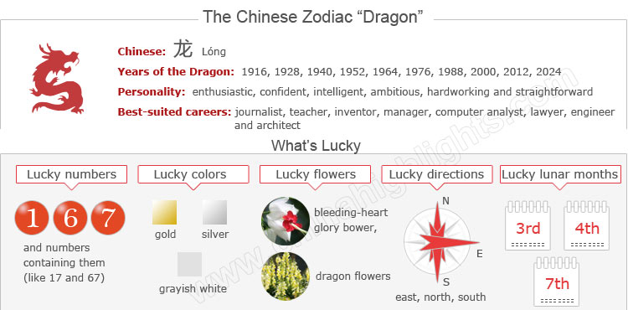

Years of the Dragon Are Unlucky for Dragons!

According to Chinese tradition, when the year of your birth sign comes around it is believed to be bad luck. It is called one’s Ben Ming Nian (本命年 běnmìngnián /bnn-ming-nyen/ ‘origin (of) life year’).

The Ben Ming Nian is a whole year of bad luck. Generally all aspects of your life, including love, health, career and finance, will not go well. Therefore “Dragons” should be more careful in years of the Dragon. Read more on [How to Be Lucky in Your Ben Ming Nian](http://www.chinahighlights.com/travelguide/chinese-zodiac/how-to-bring-yourself-good-luck-on-ben-ming-nian.htm).

The next Dragon Year is 2024. It starts on Chinese New Year (February 10, 2024). Those born in January or February should take particular note of when Chinese New Year falls to confirm their birth sign.

Choose your date of birth and find out about your Chinese zodiac sign.



The Dragon’s Personality: Confident, Intelligent...

Among Chinese zodiac animals, the Dragon is the sole imaginary animal. The Dragon is the most vital and powerful beast in the Chinese zodiac, although with an infamous reputation for being a hothead and possessing a sharp tongue. In ancient times, people thought that Dragons could control everything in the world with their character traits of dominance and ambition.

Gifted with innate courage, tenacity and intelligence, dragons are enthusiastic and confident. They are not afraid of challenges, and willing to take risks.

However, the dragon is sometimes regarded as aggressive, and angry dragons are not open to criticism. They don't consider themselves irritating and arrogant. Instead of following tradition, they strive for a smooth future.

Health Tips for "Dragons"

Taking the hardworking nature of Dragons into consideration, they are healthy in general. They may be stressed and suffer from periodic tension, for they like to embrace challenges and take risks.

Older people born in a Dragon year should pay more attention to the liver and gall bladder, blood, intestines, and stomach, while middle-aged and young Dragons should take care of their skin.

Yoga or taking a walk is an effective way to keep healthy, as these activities can be good for the mind as well as the bodies of Dragons.

Top Jobs or Careers for Dragons

Dragons like to embrace challenges and take risks. Jobs that allow them to test themselves are good choices. Some good careers include: journalist, teacher, inventor, manager, computer analyst, lawyer, engineer, architect, broker, and sales person.

How to Build Relationships with "Dragons"

In the search for the ideal partner, dragons might find themselves often hesitating to move forward in a relationship and/or unwilling to make a permanent commitment. When they do, however, it is their intention for it to last. Dragons are likely to have a warm, giving personality. They can be very generous to their loved ones.

The Luckiest Things for "Dragons"

* **Lucky numbers:** 1, 6 and 7
* **Lucky days:** the 1st and 16th of any Chinese lunar calendar month
* **Lucky colors:** gold, silver, grayish white
* **Lucky flowers:** bleeding-heart glory bower, dragon flowers
* **Lucky direction:** east, north, west
* **Lucky months:**the 3rd, 4th, and 7th Chinese lunar months.

Things to Avoid for “Dragons”

* **Unlucky colors:** blue, green
* **Unlucky numbers:** 3 and 8
* **Unlucky direction:** northwest
* **Unlucky months:** the 5th and 6th Chinese lunar months

Is 2015 a Lucky Year for "Dragons"?

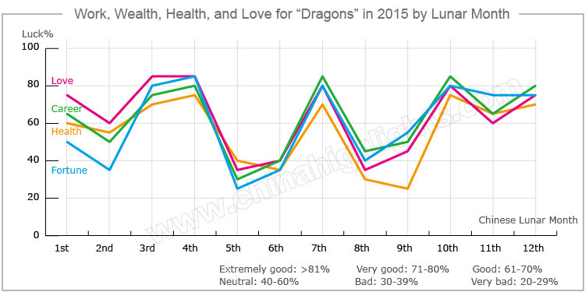

In the year of 2015, the overall fortune of the Dragon will be smooth. They will do things efficiently and successfully because they will be popular among their friends and get help from others.

Love and Relationships

The romantic life for people born in the year of the Dragon will be rather smooth in 2015, especially for those who are still single, as they will have more chances to find love.

For lovers, there will be more chance of growing a sweeter relationship. Married couples will have a harmonious life. One important thing Dragons should pay attention to is to communicate more with their partners, and make their relationship a priority, even over career and other ambitions.

Money-Making Opportunities

People born in a year of the Dragon can increase their fortune in 2015 through hard work. Office clerks should have more chances to go on business trips or attend meetings. They are expected to get extra bonuses from their bosses.

For the businessmen and investors, this year their businesses will flourish and their income will increase. Remember not to lend money to those who you do not trust very much.

How to Make Your Career Path Smoother in 2015

Dragons will have strong career luck in 2015. Fortune falls particularly upon those who have business partners of the opposite sex. They will have an opportunity to fully display their talents if they work hard enough.

When opportunities come to them, Dragons should think things through very carefully, use their better judgment, and listen to the opinions of their families and friends. As long as they work hard, they will get remarkable returns.

It will be extremely inadvisable for them to be influenced by emotions when handling people and things, or they might tumble into lawsuits.

How Can Dragons Have Good Health in 2015?

Dragons should balance work and play well, and should not exercise outside excessively, so as to avoid harming their health. They should have a balanced diet, avoid eating fried and cold food, and do more exercise.

Love Compatibility: Is She/He Compatible with You?

Each animal sign has its unique characteristics. Love compatibility within Chinese zodiac animals takes into account the characteristics of each animal. Only those whose characteristics match each other well can be good partners. See below the compatibility of the Dragon with other animals.

* **Best with:** Rat, Tiger or Snake
* **Worst with:** Ox, Goat or Dog

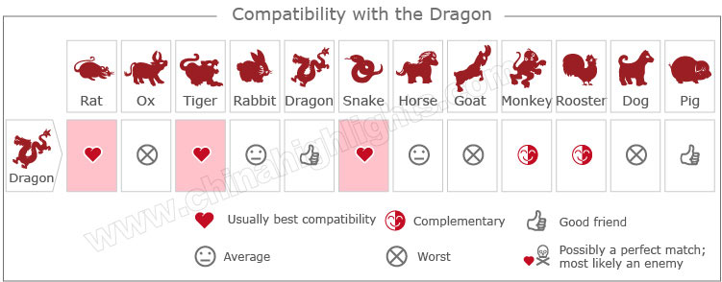

[Take our online love Compatibility test](http://www.chinahighlights.com/travelguide/chinese-zodiac/compatibility.htm)

What Type of "Dragon" Are You: Wood, Fire, Earth, Gold, or Water?

In Chinese element theory, each zodiac sign is associated with one of five elements: Gold (Metal), Wood, Water, Fire, or Earth, which means that e.g. a Wood Dragon comes once in a 60-year cycle.

|  |  |  |
| --- | --- | --- |
| **Type of Dragon** | **Year of Birth** | **Characteristics** |
| Wood Dragon | 1904, 1964 | Introverted, less enthusiastic, and lacking good relationships |
| Fire Dragon | 1916, 1976 | Smart, unreliable, and easy-going |
| Earth Dragon | 1928, 1988 | Smart, ambitious, and hardworking |
| Gold Dragon | 1940, 2000 | Natural and straightforward, unpredictable with continually changing emotions |
| Water Dragon | 1952, 2012 | Persevering, far-sighted, and vigorous |

It is theorized that a person's characteristics are decided by their birth year's zodiac animal sign and element. So there are five types of Dragons, each with different characteristics: