he Rabbit is fourth in the Chinese Zodiac. The 12-year animal cycle is: Rat, Ox, Tiger, Rabbit, Dragon, Snake, Horse, Goat, Monkey, Rooster, Dog, Pig.

* **Lucky colors:** red, pink, purple, blue
* **Lucky numbers:** 3, 4, 6
* **Lucky flowers:** plantain lily and jasmine
* **Years of birth:** 1915, 1927, 1939, 1951, 1963, 1975, 1987, 1999, 2011, 2023

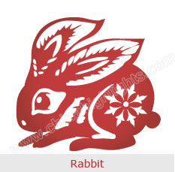

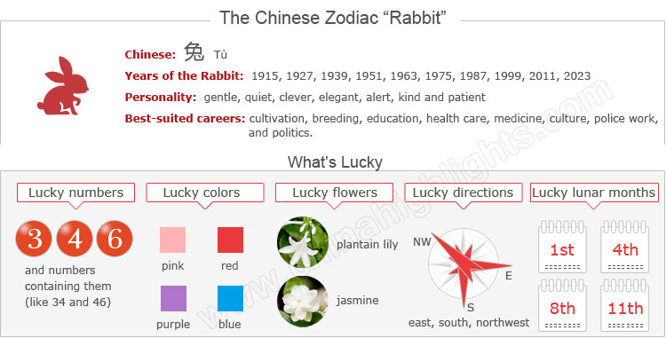

Are You a "Rabbit"?

Those born in January or February should take particular note of when Chinese New Year falls to confirm their birth sign. You can use the tool on the right to find your zodiac animal sign.

Are Rabbit Years Unlucky Years for Rabbits?

Choose your date of birth and find out about your Chinese zodiac sign.



According to Chinese culture, in the year of their birth sign (本命年 běnmìngnián /bnn-ming-nyen/ ‘origin (of) life year’) people offend Tai Sui (/tie-sway/), the god of age in Chinese mythology, and hence have bad luck.

Therefore, it is believed, Rabbits should be more careful about all aspects of their lives in Rabbit years. The next Rabbit year is 2023. It starts on Chinese New Year (January 22). Read more on [How to Be Lucky in Your Ben Ming Nian](http://www.chinahighlights.com/travelguide/chinese-zodiac/how-to-bring-yourself-good-luck-on-ben-ming-nian.htm).

The Rabbit's Personality: Quiet, Elegant...

Rabbits tend to be gentle, quiet, elegant, and alert; quick, skillful, kind, and patient; and particularly responsible. However, they might be superficial, stubborn, melancholy, and overly-discreet. Generally speaking, people who belong to the Rabbit zodiac sign have likable characters.

**Gentlemen** who belong to the rabbit zodiac sign always treat people politely, with a gentle smile that makes people feel that they are credible and sincere. When meeting trouble, Rabbits can handle it in an orderly way; when encountering tough difficulties they are never discouraged, but are persistent to seek solutions. So they eventually achieve enviable success.

**Ladies** belonging to the rabbit zodiac sign, apart from a pretty and demure appearance, have a pure heart.

Rabbits are faithful to those around them, but reluctant to reveal their minds to others, and have a tendency to escape reality. They are too cautious and conservative, which means they miss good opportunities.

Good Health for "Rabbits"

Overall Rabbits have average health. In winter to late spring, when in relatively poor health, they should do more sports to prevent colds and other infectious diseases, and have a healthy daily diet. Rabbits are advised to do some indoor exercise to cope with stress and tension.

In dry seasons, they should drink more water, and moisturize to prevent skin problems.

The Top Careers for "Rabbits"

Good-hearted Rabbits are loved by others. Intellectual, scholarly and learned, Rabbits can enjoy a good career as well as wealth. But Rabbits should take care not to give up half way when striving for something.

With a pair of dexterous hands, Rabbits have a gift for calligraphy and painting, as well as tailoring and cooking. Owning a patient temperament, they are able to manage everything to people's wishes.

**The best careers for Rabbits** are cultivation, breeding, education, religion, health care, medicine, culture, police/judiciary work, and politics.

How to Build Relationships with "Rabbit People"

Basically, you don’t have to try hard, but help them with their weaknesses.

**Strengths:** Rabbits have good social relationships. They are popular with others, as they are gentle and considerate. With a good sense of humor, they can make a dispute into a good discussion, and make enemies into friends. Possessing a gentle temperament, they are hospitable, considerate, and ready to help others.

**Weaknesses:** With an excess of universal love and charity, they may have conflicts of interest. With a lack of resolution, they have trouble with being emotionally swayed.

The Luckiest Things for "Rabbits"

* **Lucky numbers:** 3, 4, 6, and numbers containing them (like 34 and 46)
* **Lucky days:** the 26th, 27th and 29th of every Chinese lunar month
* **Lucky colors:** red, pink, purple, blue
* **Lucky flowers:** plantain lily, and jasmine
* **Lucky directions:** east, south and northwest
* **Lucky months:** the 1st, 4th, 8th, and 11th Chinese lunar months

The Unlucky Things for "Rabbits"

* **Unlucky color:** dark brown, dark yellow, white
* **Unlucky numbers:** 1, 7, and 8
* **Unlucky directions:** north, west, and southwest
* **Unlucky months:** the 2nd, 6th, 9th and 12th Chinese lunar months

Is 2015 a Lucky Year for "Rabbits"?

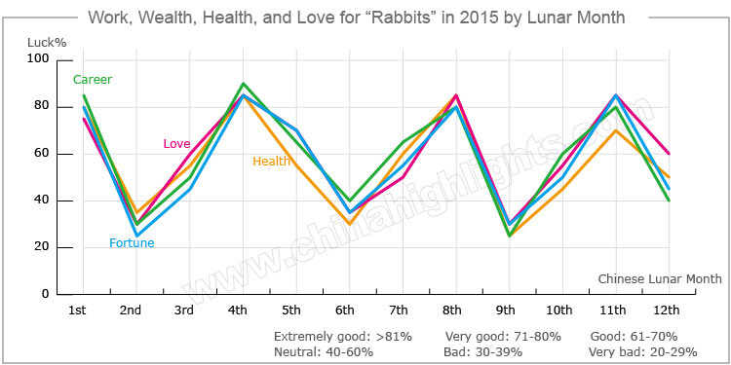

Fortune is good in 2015 in all aspects of Rabbits’ lives.

People born in a year of the Rabbit will make progress generally. They will get unexpected help from others in their jobs and lives. However, their health will not be very good. They are suggested to pay more attention to their physical condition.

Smoother Love Relationships

The romantic lives of Rabbits will be rather smooth in 2015.

**Single Rabbits** should take part in more social activities and get to know more fiends of the opposite sex. They are more likely to find true love this year.

**For Rabbits in love**, it will be a good year to get married. However, contradictions will appear between lovers and couples. When conflicts happen, Rabbits should calm down, tolerate their partners, and communicate well. Rabbits need to be patient with and care more about their partners, and not neglect them due to heavy work.

Good Financial Fortune

The overall financial fortune for people born in a year of the Rabbit will be good in 2015. As there might be unexpected expenditure, Rabbits should have a good plan for money management. When they plan business and investments, they should avoid making impulsive decisions, and listen to the opinions of their families and friends.

Optimum monetary success is more likely to occur in the 1st, 4th, 8th, and 11th Chinese lunar months. Rabbits should seize all chances to make money in these months.

Smooth Career Paths

Luck will be good in the work place in 2015 for people born in a year of the Rabbit. Rabbits will perform well in their work, and their bosses will attach importance to them. When Rabbits encounter difficulties, they will get unexpected help. They are expected to get a promotion this year.

It is advisable for them bond well with their teams, and keep good relationships with their bosses and colleagues. They should guard against gossip.

… But Bad Health

Rabbits’ physical health will not be very good in 2015. They should pay attention to avoiding chronic diseases, maintain a healthy diet, and take more exercise.

Rabbits often disagree with their bosses and colleagues at work, which prevents them from taking concerted action, and causes harm to their health due to stress. Therefore Rabbits should communicate more with their bosses to enhance mutual understanding. This will help a lot in improving their health psychologically.

On the 2nd, 3rd, and 7th Chinese lunar months, Rabbits should be more careful when they are driving or traveling to avoid accidents.

Love Compatibility of the Rabbit with Other Animals

Zodiac compatibility is based on the characteristics of the animals, and only those who match well can be good partners. See below for whether the Rabbit is compatible with your sign or not.

Rabbits are best with a Rat, Goat, Monkey, or Dog; worst with a Rooster or Snake.

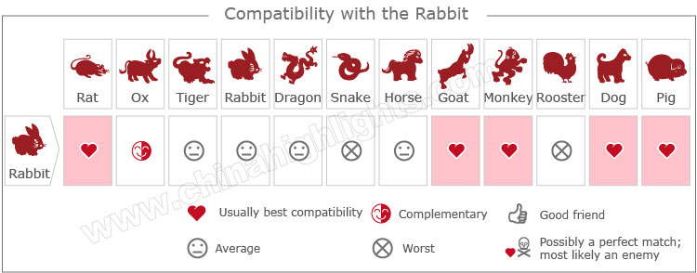

[Take our online love Compatibility test.](http://www.chinahighlights.com/travelguide/chinese-zodiac/compatibility.htm)

Five Types of "Rabbit" — Which One Are You?

In Chinese element theory, each zodiac sign is associated with one of the five elements: Gold (Metal), Wood, Water, Fire, and Earth, so, for example, a Wood Rabbit comes around once in 60 years.

|  |  |  |
| --- | --- | --- |
| **Type of Rabbit** | **Year of Birth** | **Characteristics** |
| Wood Rabbit | 1915, 1975 | Clever, quick-witted, selfish, lively in appearance, but shrewd at heart |
| Fire Rabbit | 1927, 1987 | Broad-minded, smart, and flexible, with unique views |
| Earth Rabbit | 1939, 1999 | Frank, straightforward, ambitious, hard-working, but slightly reserved |
| Gold Rabbit | 1951, 2011 | Kind-hearted, conservative, lively and enthusiastic |
| Water Rabbit | 1963, 2023 | Gentle, amicable, able to adjust readily to different conditions, but with a weak mindset and principles |

It is theorized that a person's characteristics are decided by their birth year's zodiac animal sign and element. So there are five types of Rabbits, each with different characteristics: